# Mindset Week 10

Final mindset session

Levelling up your skills and abilities

Recapped:

* Having talked about throwing ourselves in to the course
* It can get overwhelming
* The 3 zones (comfort, stretch and anxiety – learning happens in the stretch and eventually the comfort zone expands to encompass stretch and then stretch and anxiety become further out)

Today we will cover:

Personal reflection and action

Team reflection and action

An opportunity to decide how you want to develop over the rest of the programme

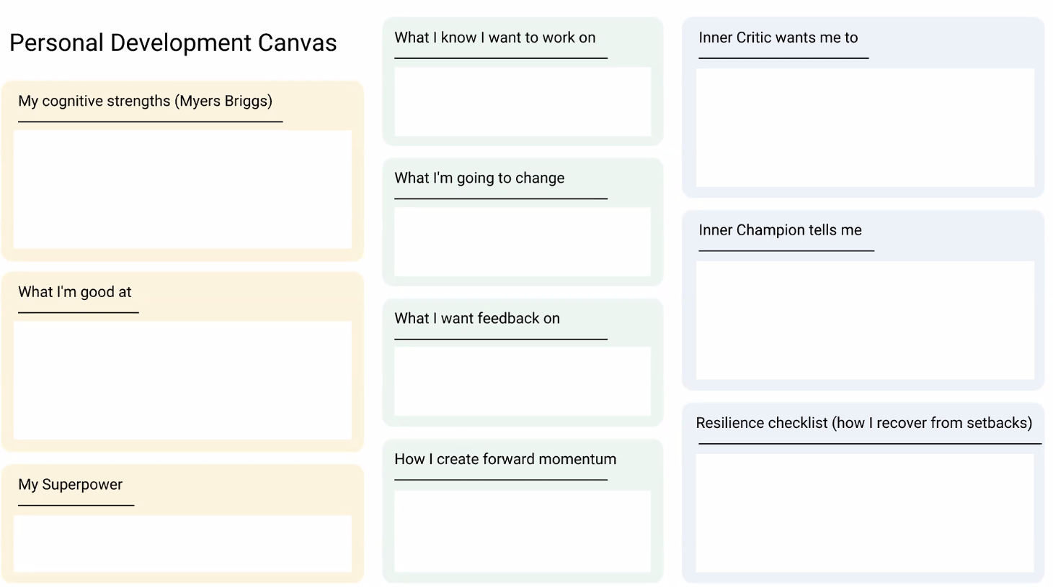

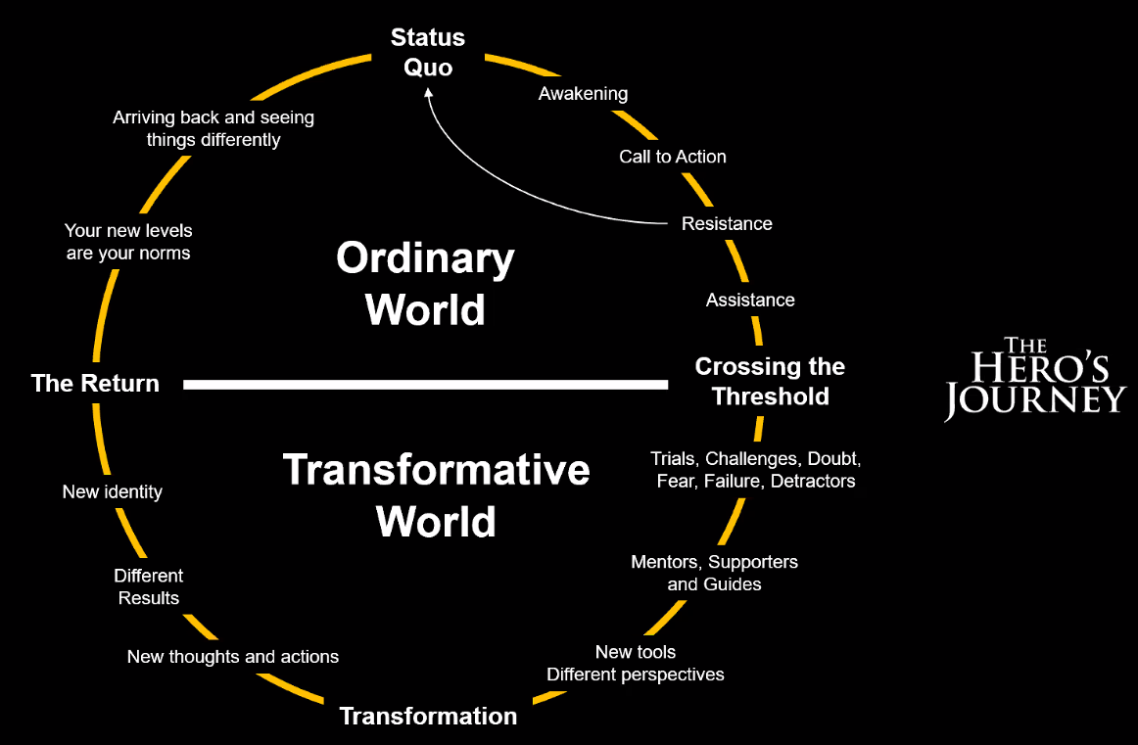

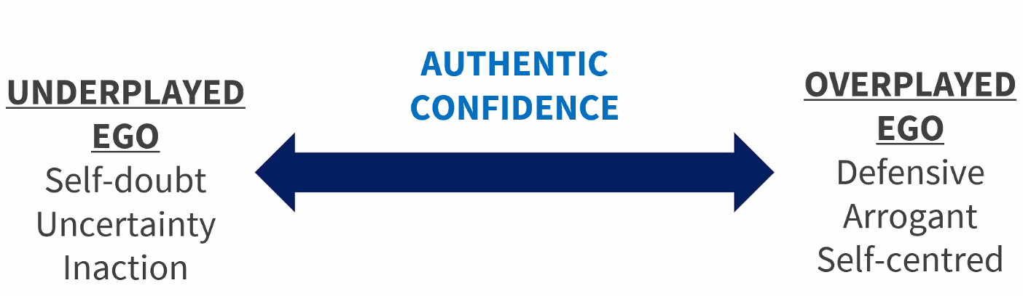

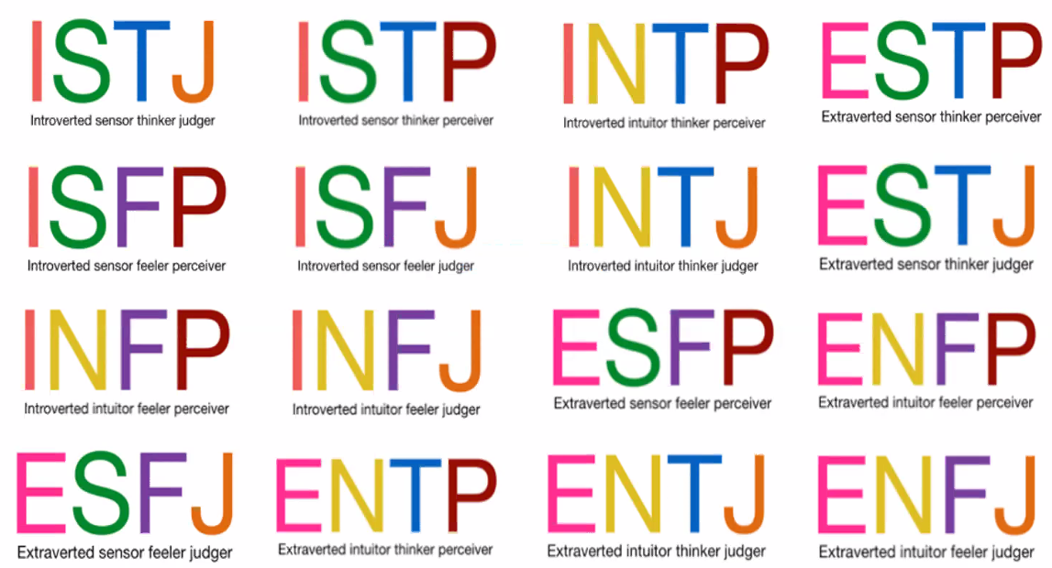

Remember the dark side of the above personalities as well as the good:

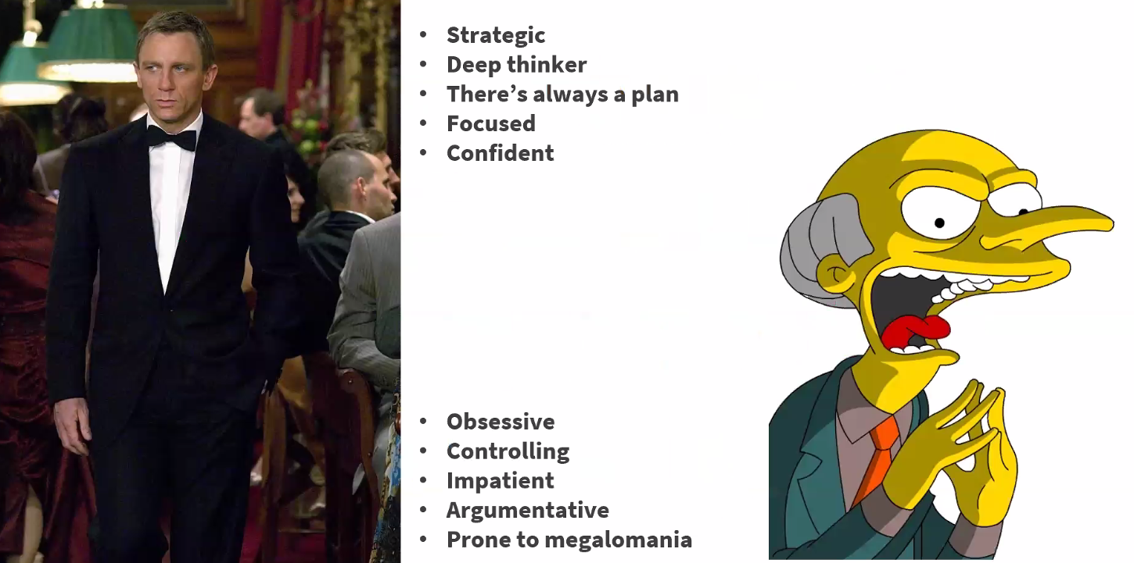

Inner critic but remember you have an inner champion as well:

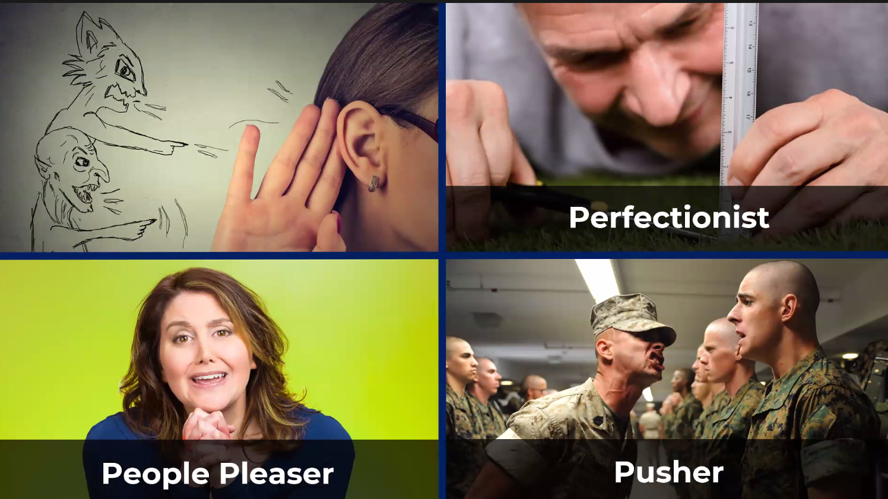

Remember the Amygdala is what’s triggering the fear!

You have superpowers – you just don’t think that’s what they are! But if you can identify them, it will help you focus less on your weaknesses. They may be living in the blind self, so asking for feedback is the only way to access things in the blind self:

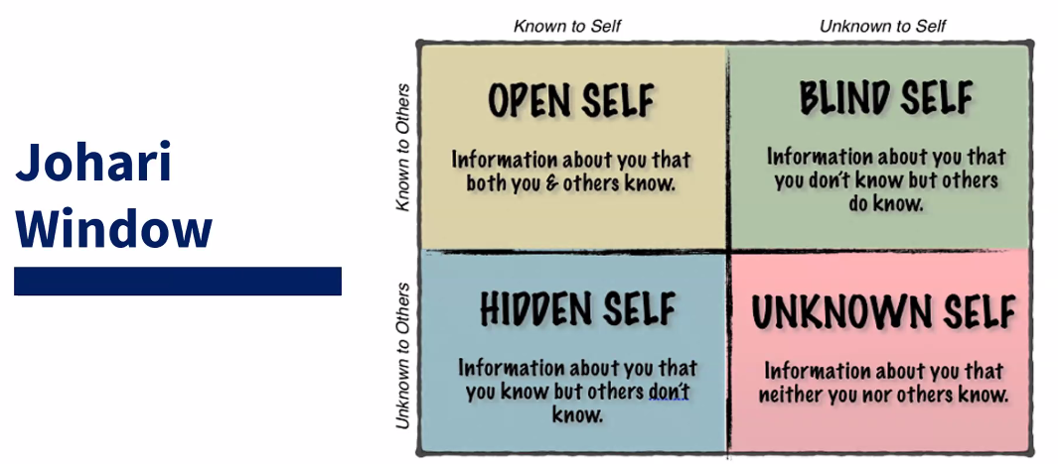

Remember feedback is a GIFT! So be grateful for it.

Keep in mind what the motive is behind giving feedback – is it for self-gratification or is it to help improve the person/situation? Keep the motive pure.

Personal reflection – the more reflective you are, the more effective you are.

1st activity of the session was to reflect personally:

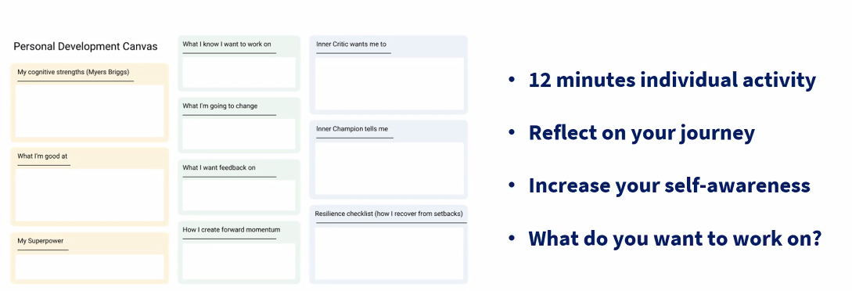

Remember the bad listener types:

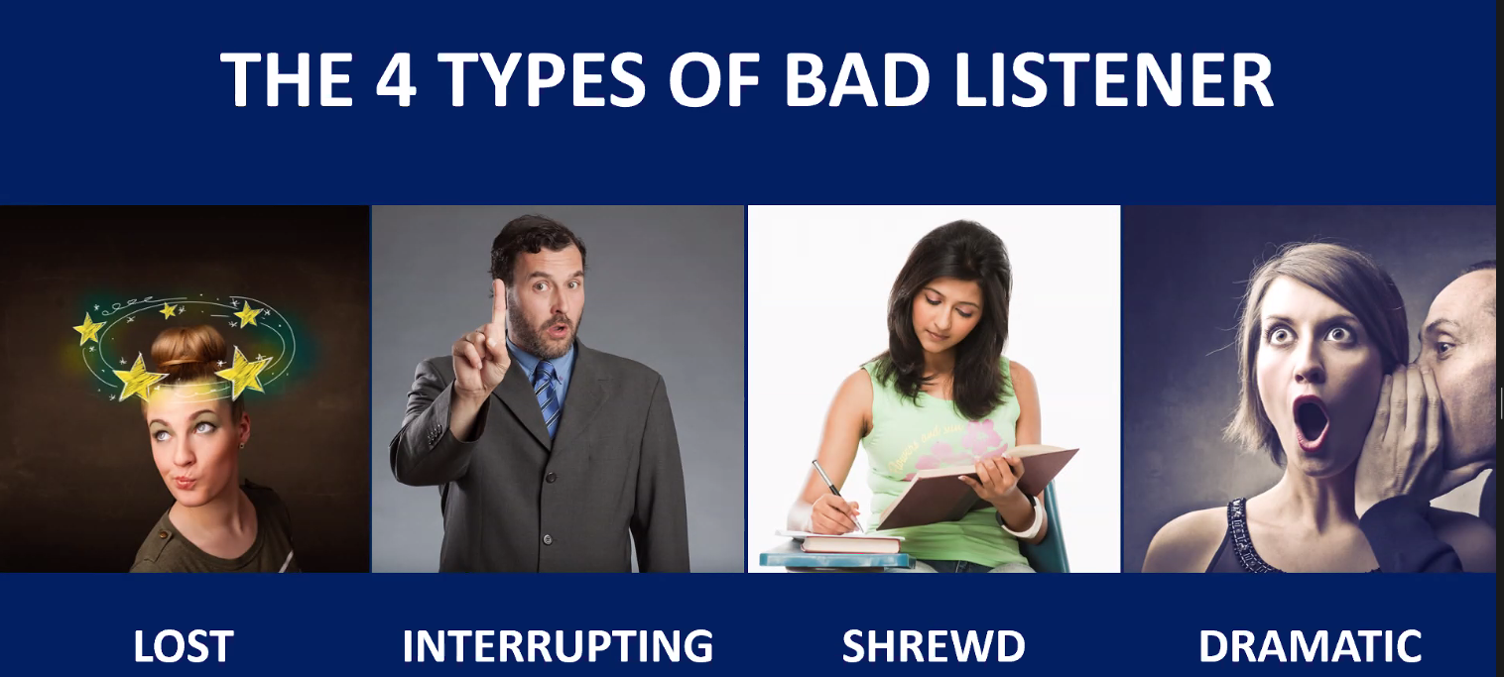

Conversation types, try to always be generative if you can, or agree to disagree in positional conversations (nobody has to “win”, respect your differences):

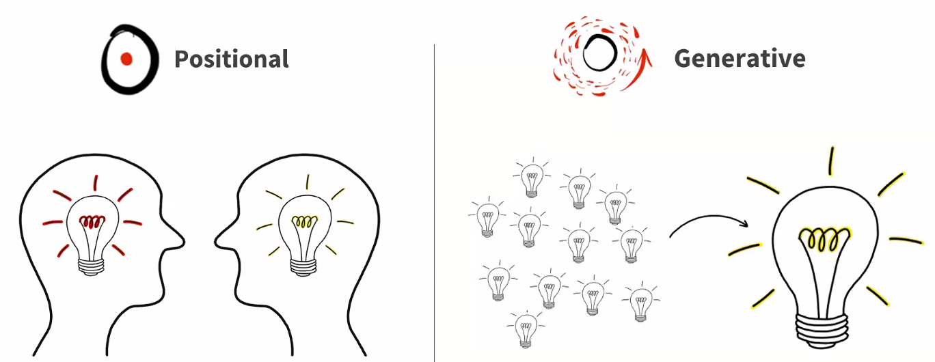

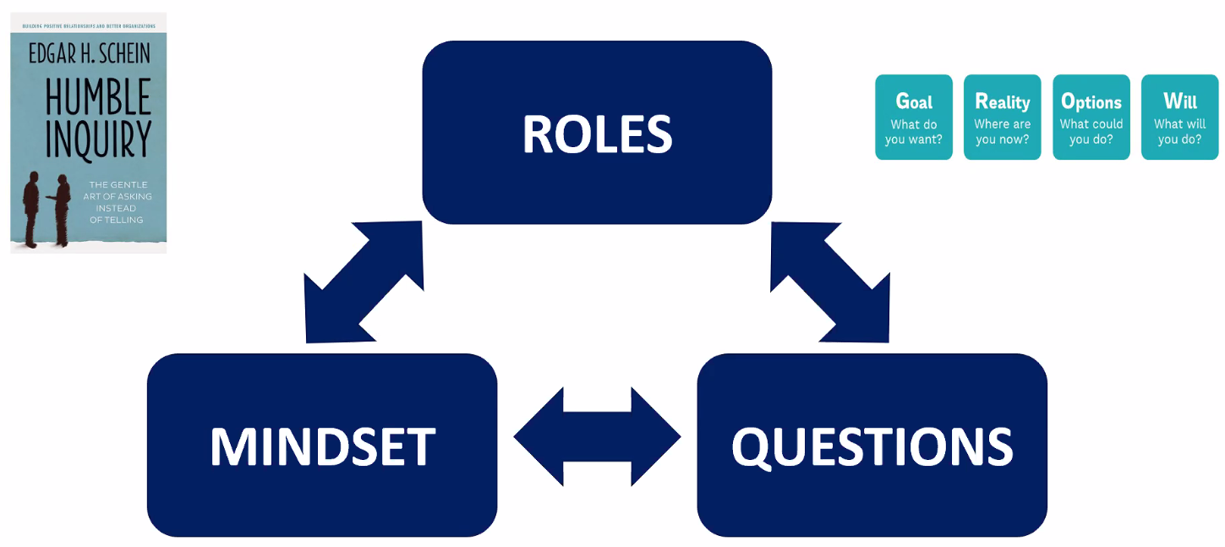

Remember to always try and create a team manifesto, and remember all the decision making tools (roman voting, dot voting etc.)

Remember, most teams get to collaboration, but the ultimate goal is co-elevation:

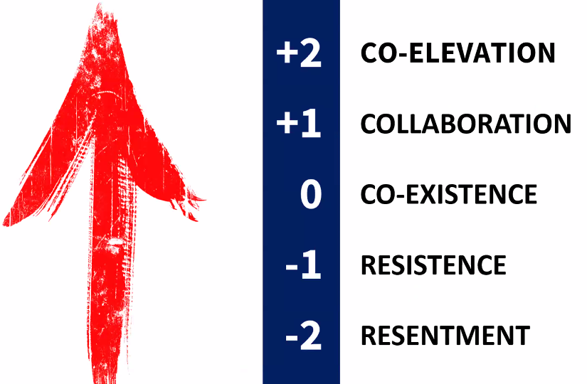

2nd activity was to reflect on your team:

We then discussed this in random breakout rooms to hear about others’ experience with teams

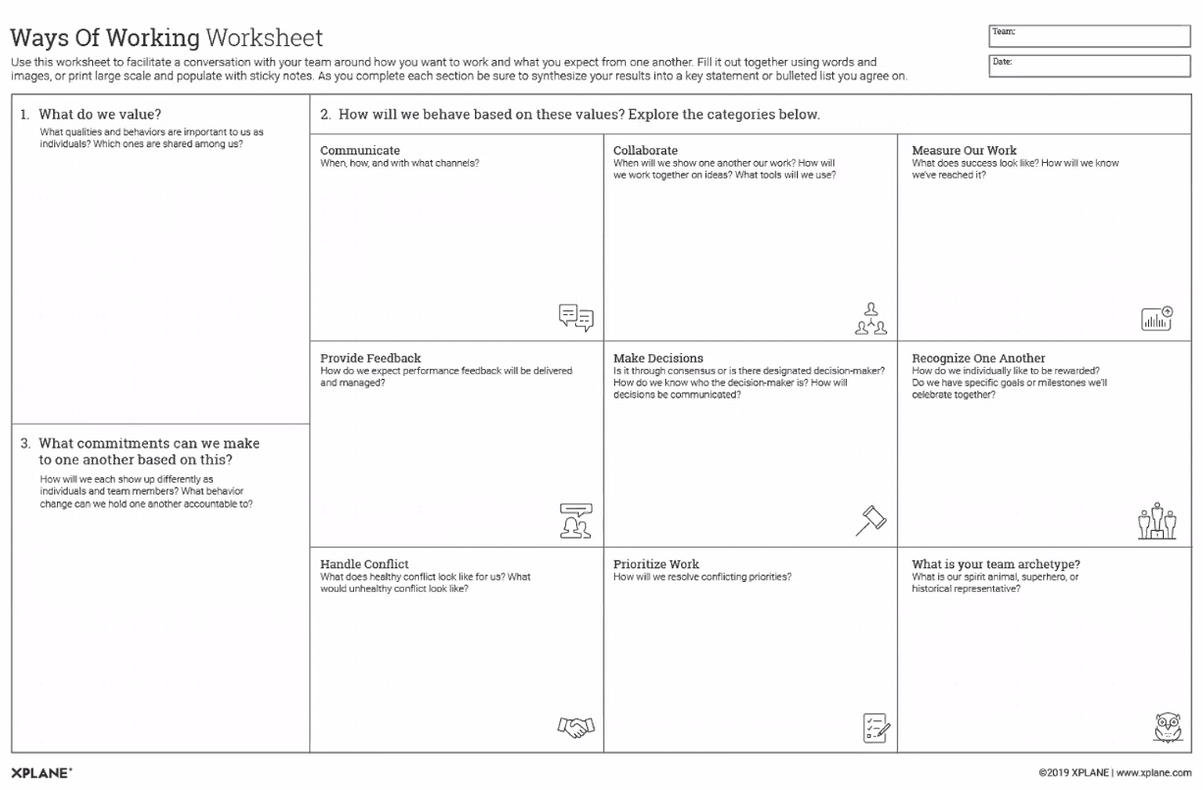

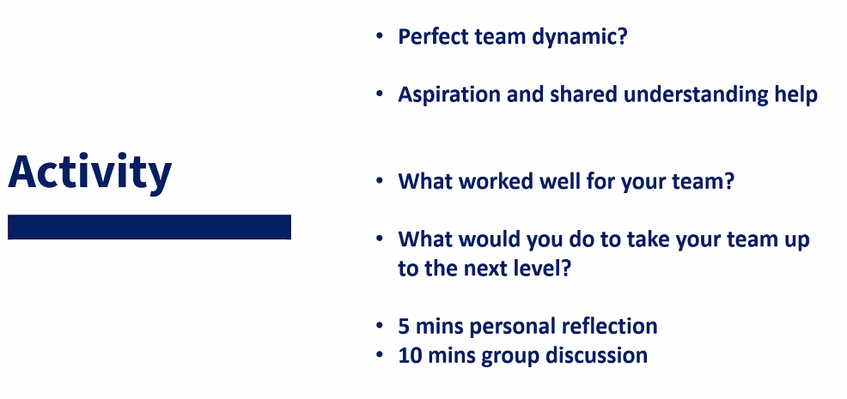

Is there a perfect team dynamic? Joe thinks probably not, he’s never been part of one!

Don’t just ask “What would you do” about taking the team up to the next level, also consider “What could the team do”.